Chemical equilibrium

1、(Little hard tricky problem)There exists an equilibrium that $2NO_{2}(g)⇋N_{2}O_{4}(g)$ $ΔH=−57KJ$. Given that the color of NO2 is Reddish brown, and the gas N2O4 has no color. Now, assume that there exists a system with NO2, N2O4, which reaches the equilibrium state.

Please choose the **true** statement(s): _____________________

1. The chemical equilibrium constant of the reaction decreases with the increase of temperature.
2. If we increase the pressure, the color of the gas will become deeper.
3. If we add some N2O4 in to the system, the equilibrium will move to the direction of **reverse reaction**(to the **left**)
4. The positive reaction is an endothermic reaction.

3、(Easy problem)The experiments have pointed out that, the density of anhydrous aluminum chloride measured in a standard thermodynamic pressure in different temperature is that:

|  |  |  |  |
| --- | --- | --- | --- |
| T/℃ | 200 | 600 | 800 |
| ρ/kg·L-1 | 6.8x10-3 | 2.65x10-3 | 1.51x10-3 |

1. Write the molecular formula of aluminum chloride at 200 ℃ and 800 ℃
2. What substances exist in the equilibrium state in 600℃?
3. Please calculate the partial pressure of the substances that exist in the equilibrium state in 600℃
4. Find out the Kc and Kp in 600℃

Acid and base

1. (Easy problem)Please compare the concentration of all the ions that are in an 0.01mol/L NaHCO3 solution and place them from the largest to the smallest and give your reason(Ka1 H2CO3=4.4*10-7,Ka2=4.7*10^(-11)):
2. (Normal problem)The metal Ag will react with HCN solution, in order to prevent the formation of the poisonous acid HCN, the reaction should take place in the solution whose PH>10:
3. What is the concentration of the solution NaCN whose PH=10.7? Given that Pka HCN=9.31
4. In the NaCN solution whose concentration is 0.02mol/L that contains Ag+,NaCN is excessive, so in the NaCN solution with PH=10.7, there exists the following equilibrium:

 Kf=5*1020

Please determine the value of 

1. Add Acid or Base in to the solution in (2) to make the concentration of the Ag+ 10 times of the concentration in (2), please calculate the concentration of CN- at this situation(ignore the volume change of the solution caused by the addition of the acid or base).
2. A small amount of phosphoric acid is used as a flavoring agent for cola, a bottle of cola has a density of about 1 gram per milliliter and contains 0.05% phosphoric acid (mass fraction)。

At 25 ℃, the tertiary ionization constant of phosphoric acid is pKa1 = 2.12 pKa2 = 7.21, and pKa3 = 12.32.

1. (very easy problem)Please calculate the concentration of [HPO42-] in Cola and the PH value of Cola.
2. (Normal problem)The following balance of bone calcium and blood calcium exists in the human body.

$$CaCO_{3}(s,Bone calcium)⇆Ca^{2+}(aq,Blood calcium)+C{O_{3}}^{2−}(aq)$$

If you drink cola and phosphoric acid enters your body, the following reactions may occur

$$3CaCO_{3}(s)+{2H}_{3}PO_{4}⇄Ca_{3}{(PO_{4})}_{2}(s)+3H_{2}CO_{3}(aq)$$

Known that Ksp(CaCO3)=4.96*10^(-9) Ksp(Ca3(PO4)2)=2.07*10^(-33)

Please use calculation to prove or disprove this reaction may or may not happen in the above condition and judge whether drinking cola will cause bone’s problem according to your calculation .

1. (Relatively Hard problem)

For H3PO4,Ka1,Ka2,Ka3 have much difference in their value.So we can use Methyl orange to titrate H3PO4 to H2PO4-,and we can use Phenolphthalein to titrate H2PO4- to HPO42-.

Pyrophosphate is a special kind of phosphoric acid, its molecular structure is shown in the figure below (can be seen as two molecules of phosphoric acid stripped of one molecule of water to form)

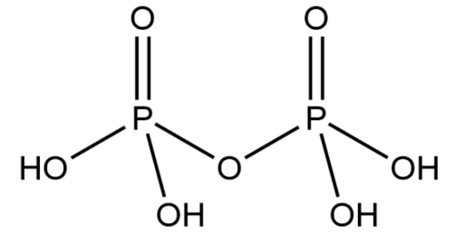

In this molecule, $Ka1≈Ka2$ but Ka1,Ka2>>Ka3, Ka4, which means that there are only two H+ will be easy to come out.

Now we consider the following Poly n phosphoric acid with the molecule formula:

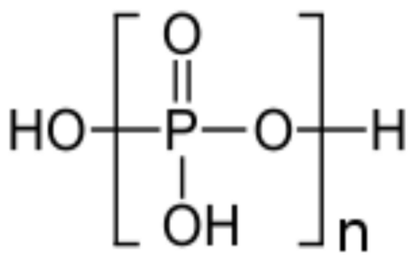

We can use NaOH to titrate the first and second H+ at the same time, and there exists two titration endpoint at V(NaOH)=42.0ml and 50.0ml. Please calculate the average number of Phosphorus atom in this kind of acid.

Kinetics

1. （Little hard problm）There exists an equilibrium A ⇌ B ⇌ C , the object product is substance B. If we increase the temperature, it is beneficial to increase the yield of product.E1,E2,E3 refer to the activation energy of A,B,C respectively. The phenomenon above indicates that __________
2. E1>E2，E1>E3
3. E2>E1,E2>E3
4. E1＜E2,E1＜E3
5. E3＞E1，E3＞E2
6. E2＜E1,E2＜E3

2、(Extremely Hard Problem)Water is a common solvent, and many reactions can take place in water. The reaction :

$$M+B=P$$

can be carried out in water.

The reaction shall be homogeneous acid-base catalytic reaction. In order to study the mechanism of the reaction, several experiments were carried out on the aqueous solution system containing M, B and P. Based on the obtained data, the researchers proposed two possible reaction mechanisms, as follows:

Mechanism 1: Mechanism 2:

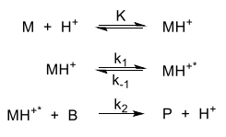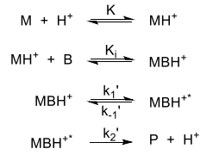

In the above mechanism, MH+ * and MBH+ * are unstable active intermediates, and the elementary reaction without giving the rate constant in the above mechanism is rapid equilibrium,which does not affect the speed of the reaction.

When solving this problem, you can use **speed control step approximation, equilibrium approximation, steady-state approximation** and other methods to make reasonable approximation.

When solving this problem, C0 represents the initial concentration and C represents the concentration at time t. For example, C0, B is the initial concentration of B, and CB is the concentration of B at time t.

Under the condition of no acid catalysis, the experimental results show that the k'obs of the reaction is very small, which is almost negligible compared with acid catalysis.The kinetic experiment was carried out at 298K and 303k, and the obtained data were fitted as follows:

|  |  |  |
| --- | --- | --- |
| Trial | k’obs (L·mol-1·s-1) | T(K) |
| 1 | 5.42 × 10-9 | 298 |
| 2 | 1.62 × 10-8 | 303 |

1. It is known that the reaction M + B = P follows the Arrhenius theorem, please calculate the the activation energy of the reaction Ea when temperature range is 298K ~ 303K and there is no acid catalysis.
2. kinetic experiments show that when the concentration of B is large, dCP / dt(reaction speed) has nothing to do with CB. Based on this conclusion, judge which one of the two mechanisms might be the correct one for the reaction and explain the reason by calculation.
3. Under the condition of acid catalysis, when the concentration of B is large, the apparent rate constant of the reaction is k’obs = 2.79 × 10-4 mol · L-1 · s-1. If the initial concentration of B is 1.00 mol · L-1 and M is large excess, calculate the half-life period of the reaction to the reactant B.